TITLE OF PAPER (14 pt, bold)

John Smith (14 pt)

Division of Mechatronics, Faculty of Mechanical Engineering, Wroclaw University of Technology
e-mail: jan.kowalski@pwr.edu.pl (10 pt, italics)

(two lines spacing, 10 pt)
Abstract. Summary having documentary character, not exceeding eight rows. The text of the summary should be written in the language of the paper, font Times New Roman 12 pt. In the abstract use bilateral indentation of 1 cm, full justification of text, using the indentation of 0,25 cm in the first line of the paragraph.
(two lines spacing, 12 pt)

1. INTRODUCTION (Times New Roman, 12 pt, capital letters)
(one line spacing, 12 pt)
It is advisable for introduction to contain synthetic discussion of presented issue with an indication of original elements of the work.
Required editor is Word for Windows (Microsoft Office 2007 or newer). Accepted will be articles with 6 or 8 pages (even number of pages) of A4 format. Full text of the paper should be written in font Times New Roman 12 pt, without line spacing, with full justification of the text, using indentation of 0,5 cm in the first line of a paragraph and keeping the layout according to the stated pattern. Margins (left, right, top and bottom) should be 2,5 cm and the distance between the top edge of the page and the heading 2 cm.
In the headings of the odd pages of the paper the title of the article aligned to the centre should be placed, while in the headings of the even pages initials and surnames of the authors aligned to the center should be placed. Titles of main chapters should be written in capital letters, while subsection titles – lower letters, bold. After the chapter titles do not put the dots.
Please send an electronic version of the paper on a data carrier to the address provided on the conference website or on email address: tmm@pwr.wroc.pl. Files should be named with authors’ surnames separated by underscore character (e.g. Kowalski_Nowak.docx).
(two lines spacing, 12 pt)

2. TITLE OF MAIN CHAPTER (Times New Roman, 12 pt, capital letters)
(one line spacing, 12 pt)
2.1. Title of subsection (Times New Roman, 12 pt, bold, letters like in the sentence)
(one line spacing, 12 pt)
Equations should be placed in the centre of the line and numbered, aligned to the right (Times New Roman, 12 pt) e.g.:
$Mx+By+Cz=0$ (1)
(one line spacing, 12 pt)
Figures and diagrams, made using any technique, should be an integral part of the text and should be captioned (Times New Roman, 12 pt). Captions are to be centered in the line and not ended with a dot. Figures and graphs should be made in such a way to make the black-and-white print legible.
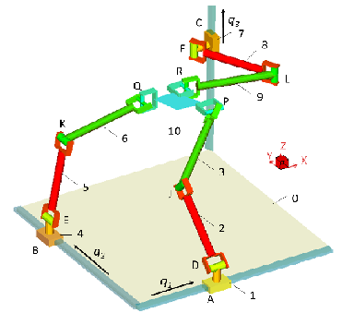
Fig.1. View of mechanism’s computational model
(one line spacing, 12 pt)
Descriptions of the tables should be located above the tables, aligned with the right edge of the table and not finished with a dot.
(one line spacing, 12 pt)
(Times New Roman, 12 pt) Table 1. Forces of interactions
Number | Forces of interactions F_{i} [N] :
 | In A joint | In B joint
1 | 376,03 | 456,00
2 | 481,08 | 403,22
3 | 581,14 | 472,84
(one line spacing, 12 pt)
List of literature used by the author should include, in addition to the position number, surnames and initials of authors, title of work:
- for books: volume, place of publication, publisher, year of publication
- for articles: title of journal, number (or volume), year of publication, pages (after abbreviation pp.)
(two lines spacing, 12 pt)

REFERENCES (Times New Roman, 12 pt, capital letters, without numbering)
(one line spacing, 12 pt)
- Nowak J.: Kinematyka i dynamika mechanizmów. Warszawa, WNT, 1986.
- Smith J.: Parallel mechanisms. Archive of mechanisms, Vol. 2, Issue 24, pp.113-125, Warszawa 2003.
(two lines spacing, 12 pt)

PAPER TITLE IN FOREIGN LANGUAGE
(one line spacing, 12 pt)
Abstract. Summary in a foreign language (English, German or Russian) format as in the beginning.

